http://madebyevan.com/fsm/
http://www.fizzim.com/examples/
http://www.graphviz.org/content/fsm
http://qfsm.sourceforge.net/download.html
http://fsme.sourceforge.net/

https://pdfs.semanticscholar.org/fc86/c86da97e1c56eb791728b5d072ae6b6d1c4f.pdf

https://inst.eecs.berkeley.edu/~cs150/sp12/resources/FSM.pdf

https://courses.cs.washington.edu/courses/cse370/10sp/pdfs/lectures/15-VerilogIIPrint.pdf

http://www.sunburst-design.com/papers/CummingsICU2002_FSMFundamentals.pdf
https://books.google.fr/books?id=DxQGrz7q-SwC&pg=PA56&lpg=PA56&dq=verilog+state+machine+with+loops&source=bl&ots=efhaWYuMAf&sig=lAurMiysqtO9H5y77Q0JF3OoJEE&hl=fr&sa=X&ved=0ahUKEwjbwv_C7c3XAhWELcAKHXVPBC0Q6AEIZjAH#v=onepage&q=verilog%20state%20machine%20with%20loops&f=false
https://github.com/stffrdhrn/adc_interface/blob/master/rtl/adc_interface.v

https://subodhtripathi.files.wordpress.com/2013/11/adc_interfacing.pdf
http://www.ti.com/lit/an/slaa199/slaa199.pdf
http://www2.dc.ufscar.br/~marcondes/netfpga/FPGAPrototypingByVerilogExamples.pdf
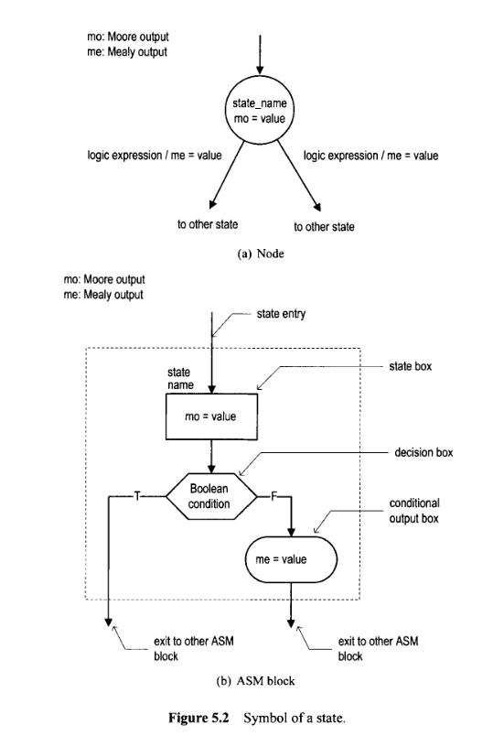

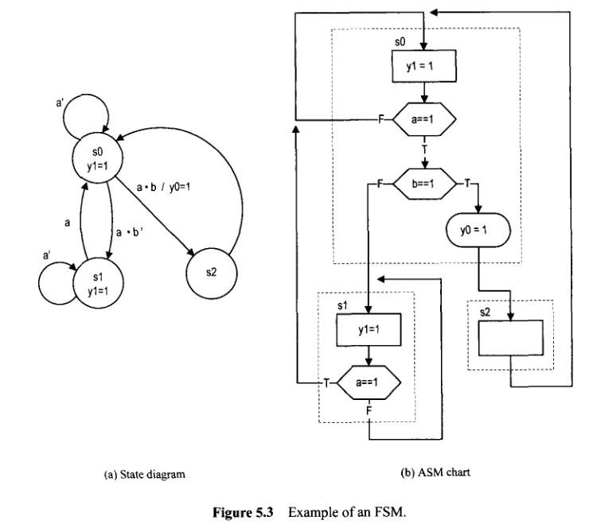

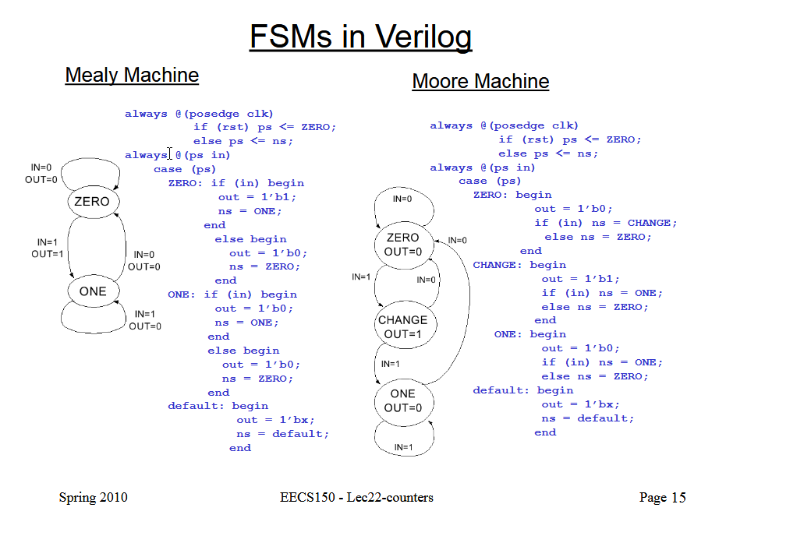
always @(posedge clk) begin
n <= n-2'h01; -- thats the counter
if(n==2'h02) begin
m <=8'h02;
end
if(n==2'h01) begin
m <=8'h03;
end
if(n==2'h00) begin
m <=8'h04;
end
end

// 4-State Moore state machine

// A Moore machine's outputs are dependent only on the current state.
// The output is written only when the state changes. (State
// transitions are synchronous.)

module moore_mac
(
input clk, data_in, reset,
output reg [1:0] data_out
);

// Declare state register
reg [1:0]state;

// Declare states
parameter S0 = 0, S1 = 1, S2 = 2, S3 = 3;

// Output depends only on the state
always @ (state) begin
case (state)
S0:
data_out = 2'b01;
S1:
data_out = 2'b10;
S2:
data_out = 2'b11;
S3:
data_out = 2'b00;
default:
data_out = 2'b00;
endcase
end

// Determine the next state
always @ (posedge clk or posedge reset) begin
if (reset)
state <= S0;
else
case (state)
S0:
state <= S1;
S1:
if (data_in)
state <= S2;
else
state <= S1;
S2:
if (data_in)
state <= S3;
else
state <= S1;
S3:
if (data_in)
state <= S2;
else
state <= S3;
endcase
end

endmodule
module statem(clk, in, reset, out);

input clk, in, reset;
output [3:0] out;

reg [3:0] out;
reg [1:0] state;

parameter zero=0, one=1, two=2, three=3;

always @(state)
begin
case (state)
zero:
out = 4'b0000;
one:
out = 4'b0001;
two:
out = 4'b0010;
three:
out = 4'b0100;
default:
out = 4'b0000;
endcase
end

always @(posedge clk or posedge reset)
begin
if (reset)
state = zero;
else
case (state)
zero:
state = one;
one:
if (in)
state = zero;
else
state = two;
two:
state = three;
three:
state = zero;
endcase
end

endmodule

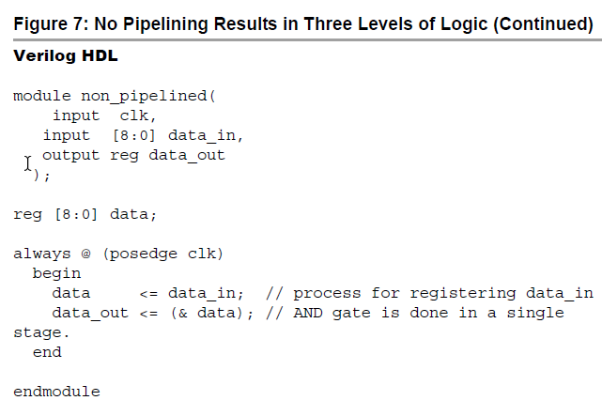

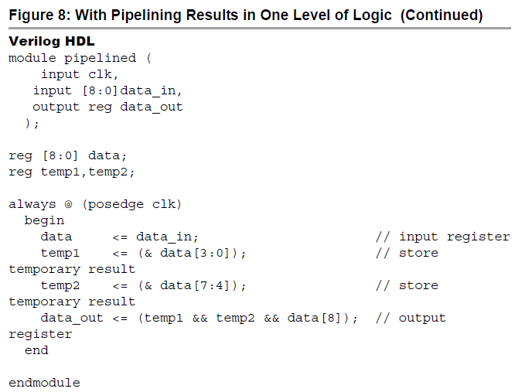
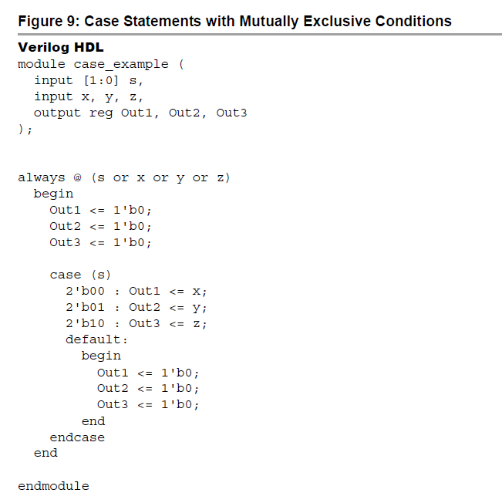

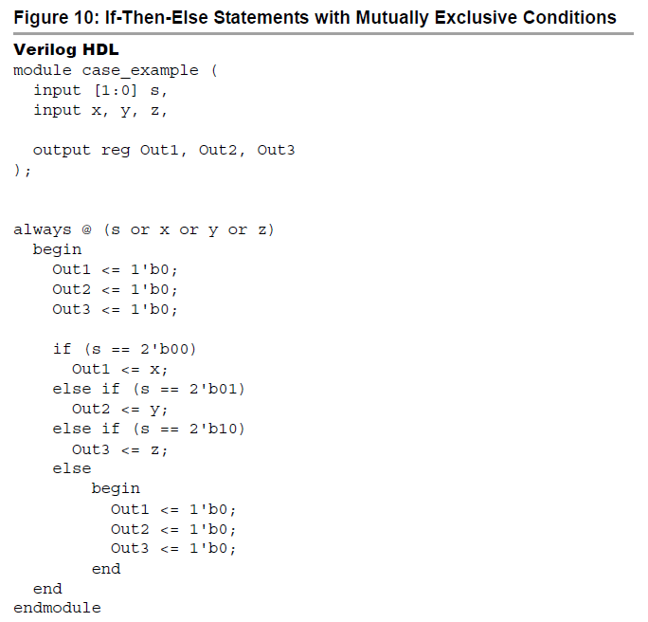

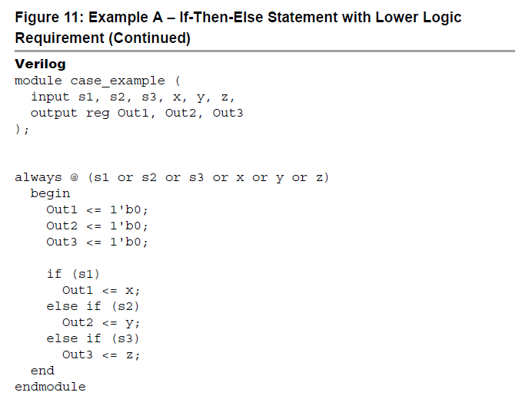

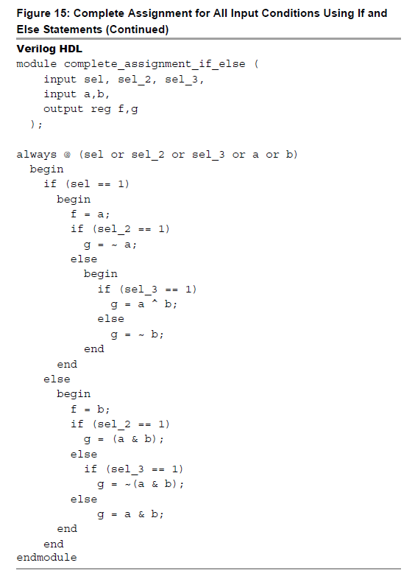
assign sel_wire = {sel_3, sel_2, sel}; // concatenate
inputs for convenience

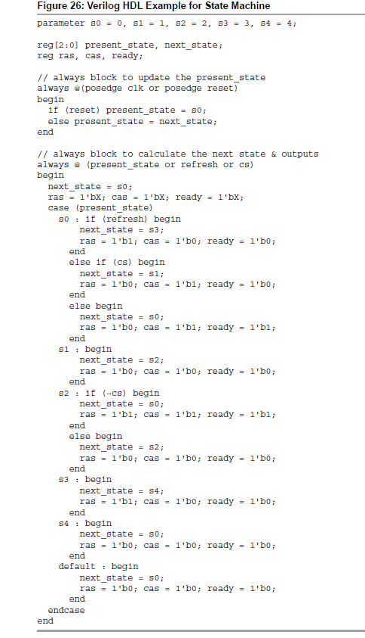

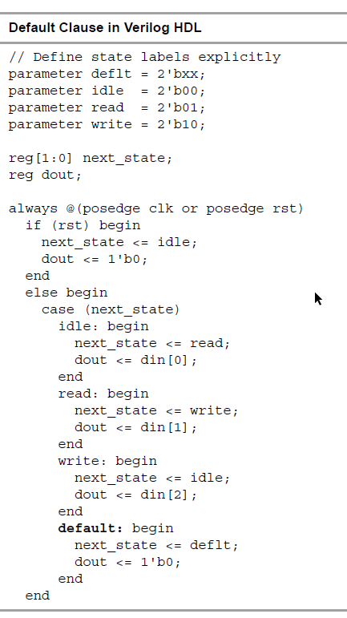
https://embeddedthoughts.com/2016/07/05/fpga-keyboard-interface/

http://www.referencedesigner.com/tutorials/verilogexamples/verilog_ex_10.php
sequencer
controller
https://www.cl.cam.ac.uk/teaching/2002/ECAD/ExtraExamples/ADCcontroller.pdf

http://referencedesigner.com/blog/level-change-detection-in-verilog/2663/
http://fpgacenter.com/examples/basic/edge_detector.php

always @(enable or lights_in) begin
#10
if (!( ( enable && lights_out = = lights_in) ||(!enable && lights_out = = 3'b000) ))
$display("Error in light controller output");
end

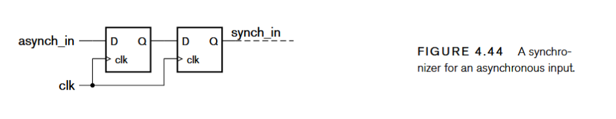

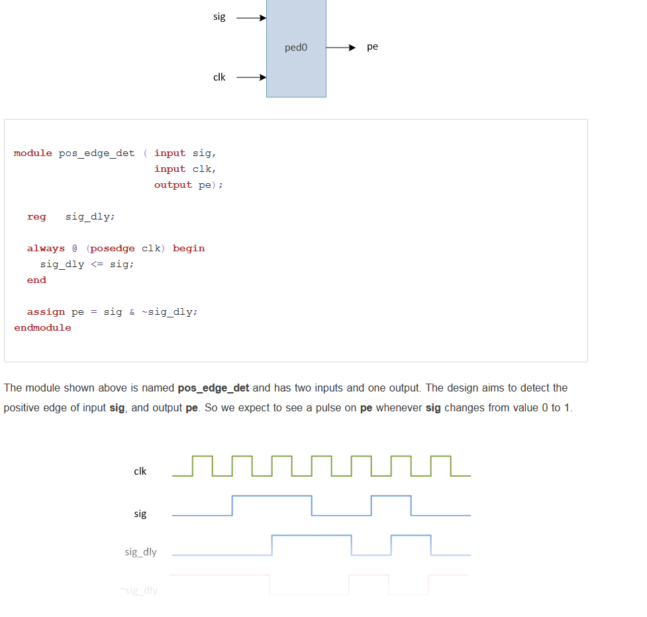
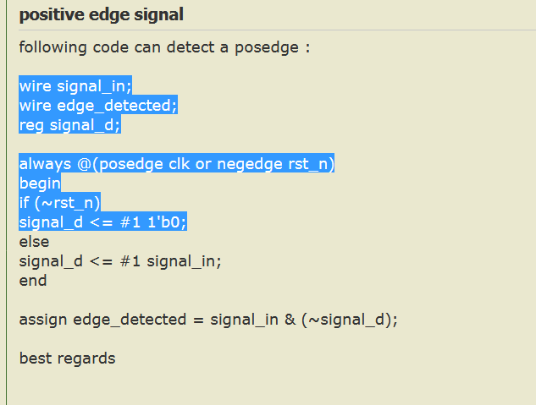

output that changes on the rising edge of CLK, ...

RUN1 6 conversion et enchainment 5 6 adc_pd remonte trop tot
Les autres RUNS 5 conversion , la premiére 5 6 5 6 puis 5 6 adc_pd remonte trop tot

Premier enable clock suivante ON
Les autres enable clock suivante ON puis enable passage 0 avant de revenir à 1

